**IST1040B: INTRODUCTION TO WEB APPLICATIONS AND DESIGN**

**SUMMER SEMESTER (US) 2024**

**END SEMESTER EXAM**

**Practical Exam: To-Do List Application**

Dustine Kibagendi 670797

**DATE:** Thursday, 08 August 2024

**Objective:**

Create a web page that allows users to manage a simple to-do list. The page should include sections for adding new tasks, viewing a list of tasks, and marking tasks as completed. This project will assess your ability to structure HTML, style with CSS, and add interactivity with JavaScript.

**Response:**

Please view the interactive weather dashboard by clicking [here](https://akstine.github.io/APT1040B_US24_To-Do-List_exam/).

If you are not automatically redirected, please copy and paste this link onto your browser: <https://akstine.github.io/APT1040B_US24_To-Do-List_exam/>

*Landing page*

The website provides an inspiration ambience to encourage the user to take charge of their time and future.

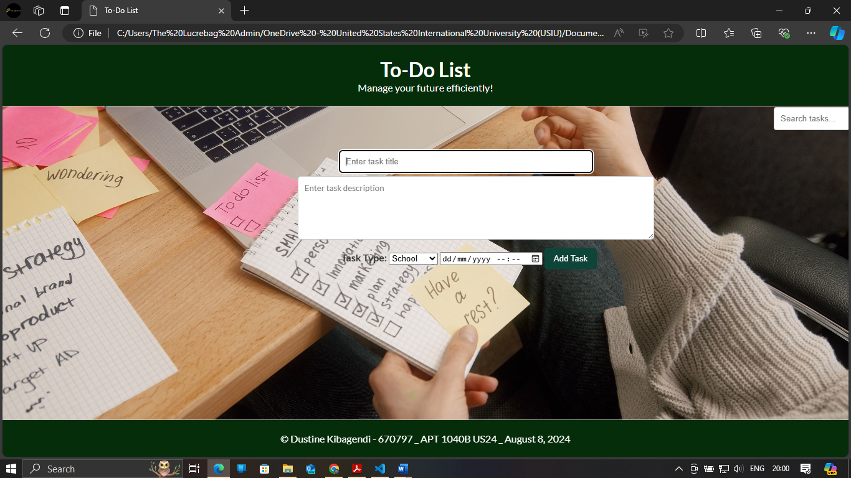

*Tasks list*

A user can specify the kind of task that they need to schedule. There is a due date for reminders. Task statuses are editable by the user and easy to ascertain due to their colour-coded nature.

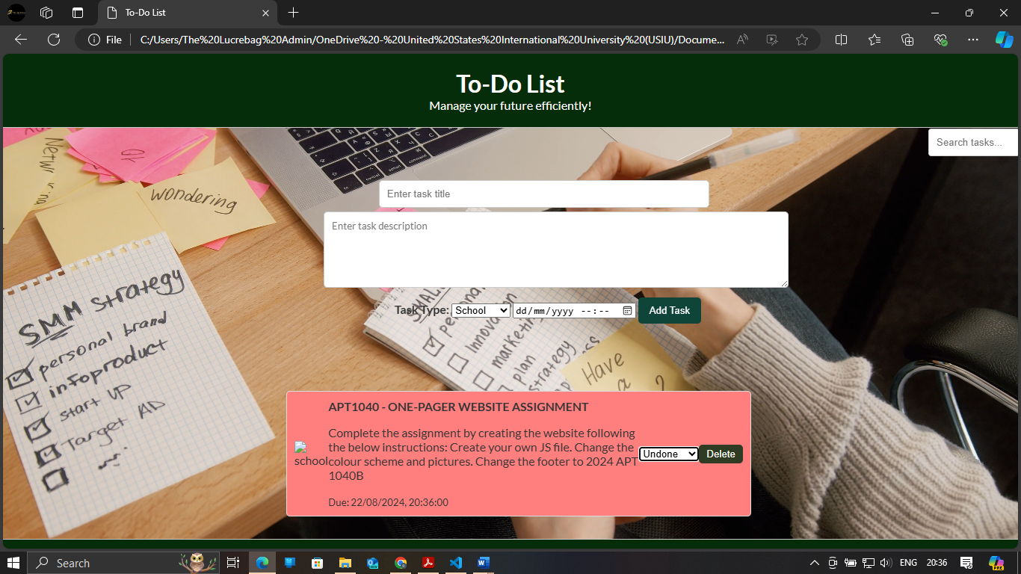 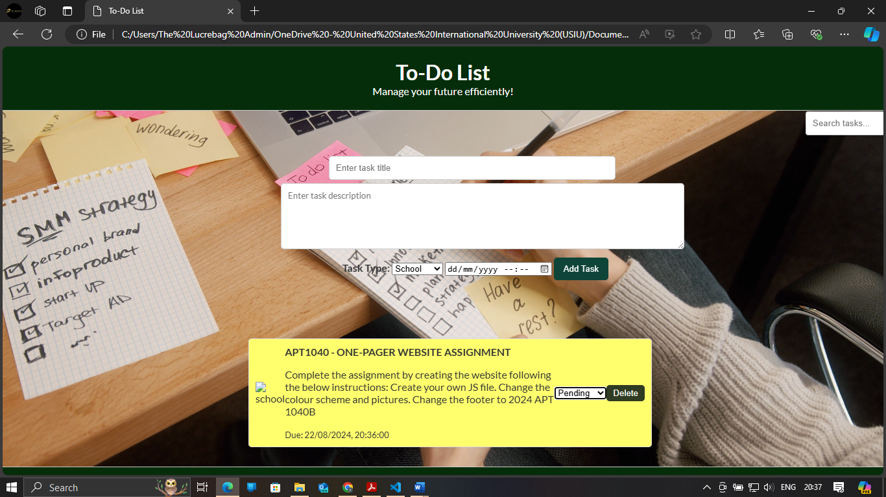 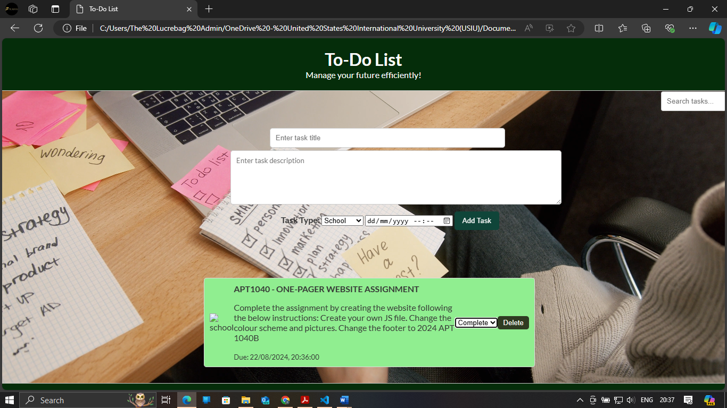

*Delete feature*

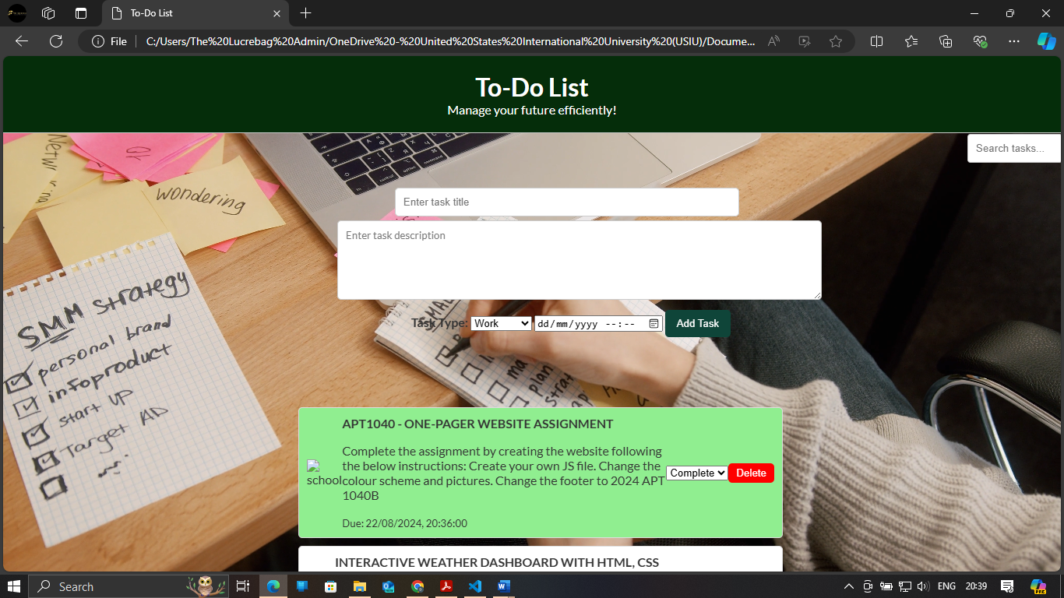

*Tasks list – next task*

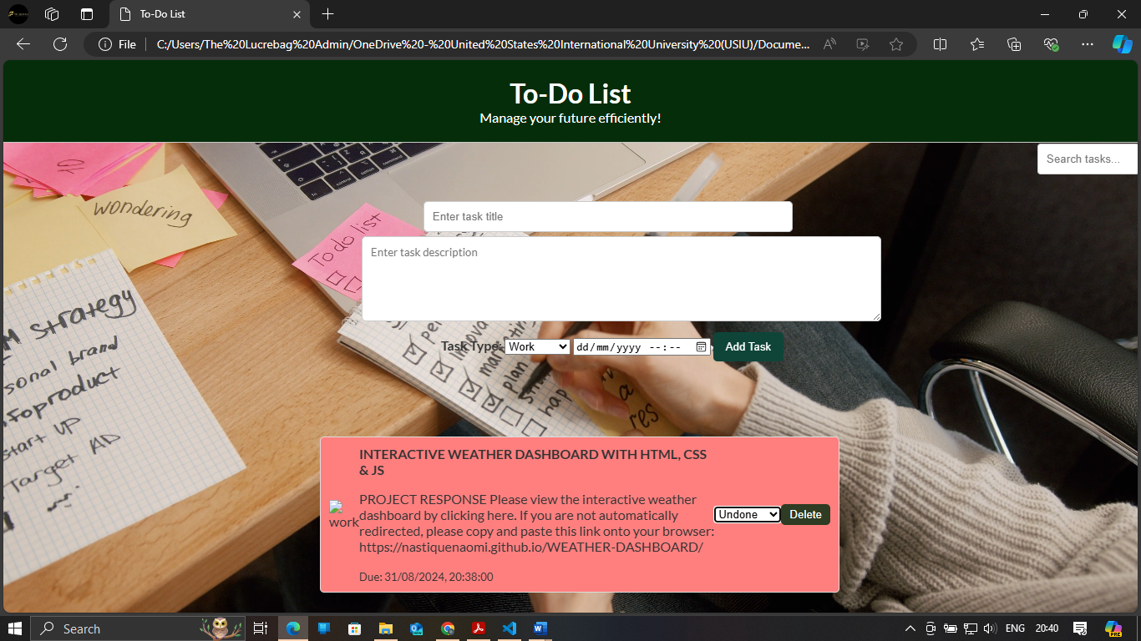 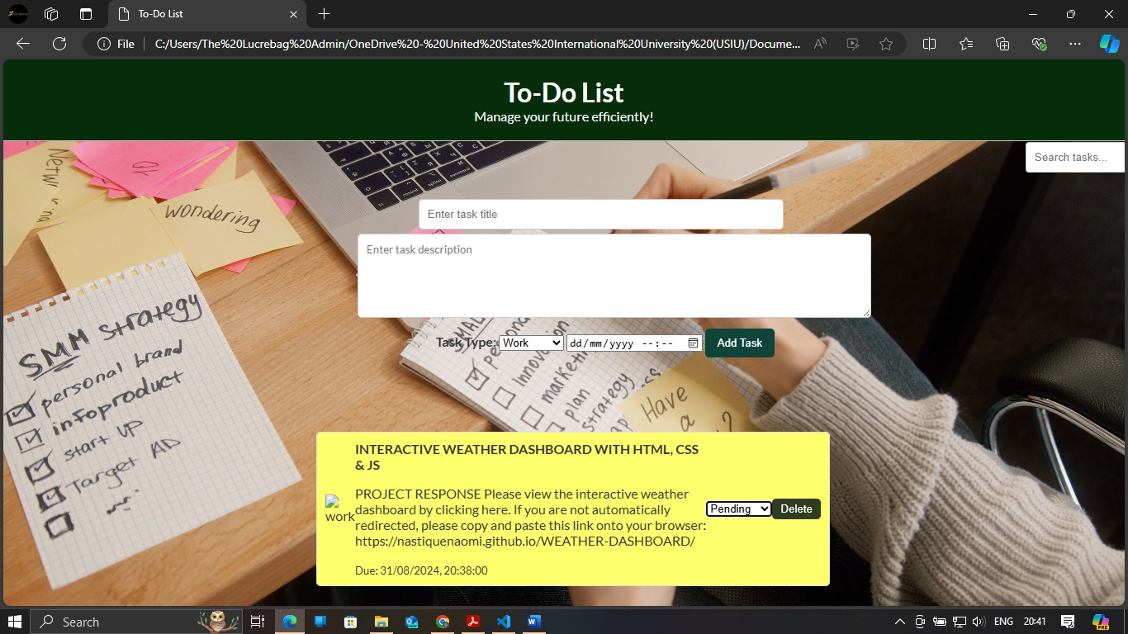 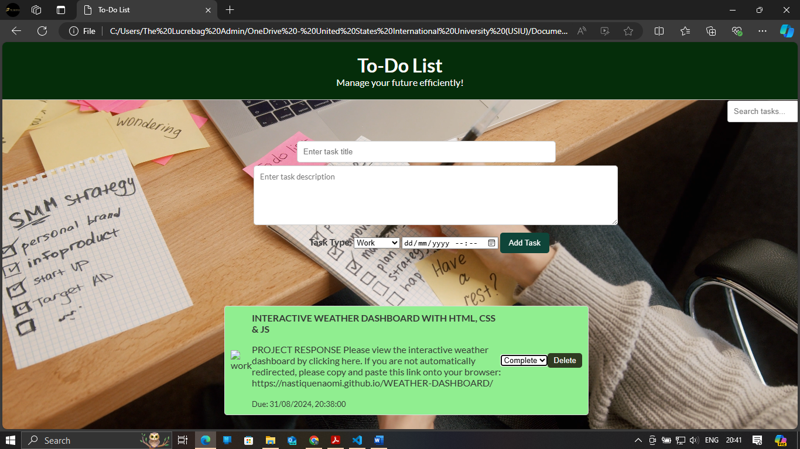

*Search feature*

